**Year 10**

**Chemistry Homework Booklet**

Name _____________________________

Class _____________________________

**Week 1: Atoms**

The radius of atoms can be calculated.

14

In Table 1 below, the atomic radii of the elements in Group 1 of the Periodic Table are listed. However, the atomic radius for potassium is missing.

Use your graph drawing skills to estimate the atomic radius of potassium.

Table 1: The atomic radii of the Group 1 elements

|  |  |  |
| --- | --- | --- |
| **Element** | **Atomic number** | **Atomic radius (picometres)** |
| *Lithium* | 3 | 167 |
| *Sodium* | 11 | 190 |
| *Potassium* | 19 | ? |
| *Rubidium* | 37 | 265 |
| *Caesium* | 55 | 298 |

Task

1. Decide on the independent and dependent variables.
2. Plot a suitable line graph for this data.
3. Draw a line of best fit.
4. Using your graph, estimate the atomic radius for potassium.

Lithium atom

radius 167 pm

Biology HSW © Badger Publishing Ltd

Independent variable _____________________

Dependent variable _____________________

Atomic Radii of Potassium (pm) _____________________

**Week 2: Limestone Research**

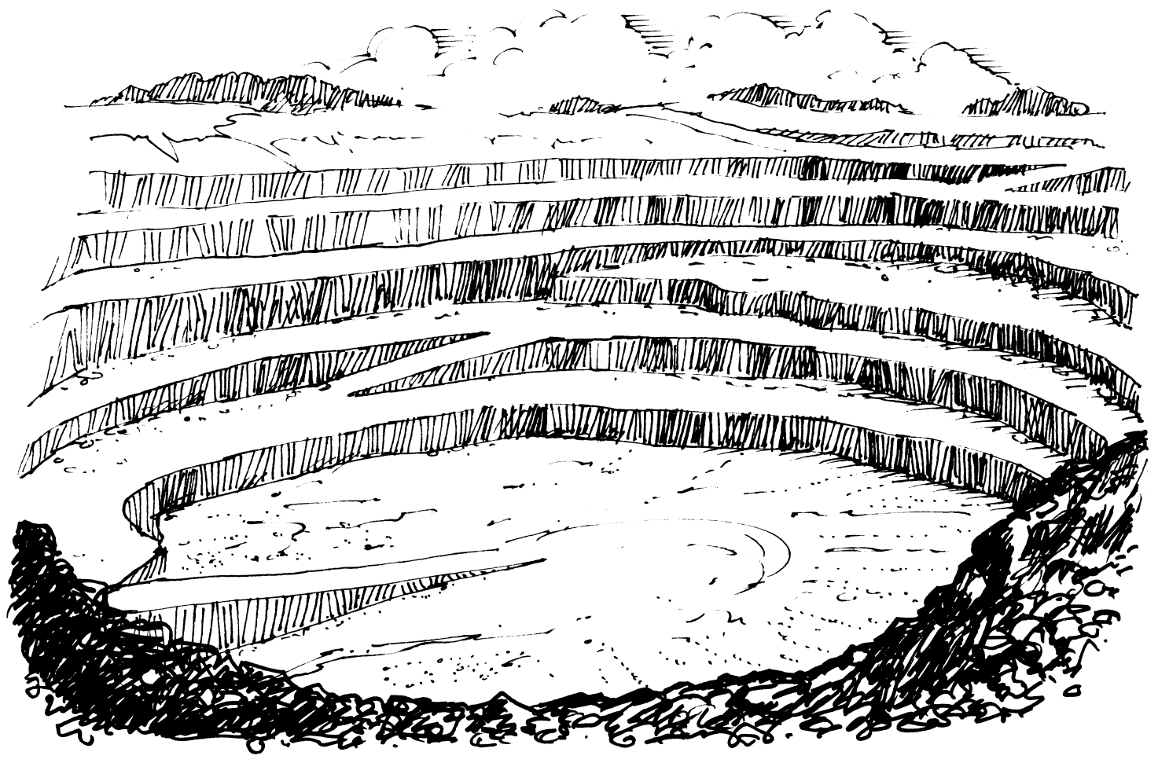

* Where is limestone extracted from in the United Kingdom?
* What is the extracted limestone used for?
* How could you find out using secondary resources?

Task

Plan to use secondary resources to find out where limestone is extracted in the UK and what it is used for.

Write down the steps you intend to take to gather scientific, reliable and accurate data.

**Include:**

* What are the questions you are trying to answer?
* What scientific evidence will you look for?
* Will you use a search engine? Which key words could you try?
* Will you use the library? Which resources will you use?
* How will you ensure your data is unbiased?

Biology HSW © Badger Publishing Ltd

**Week 3: Limestone**

Identify the **chemical name** of these compounds from their formulae:

**CaO** __________ __________

**CaCO3 _______________ _______________**

**Ca(OH)2** ____________________

# Limestone Products

What materials are needed to produce the following materials?

Cement:

Limestone

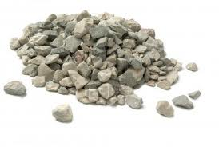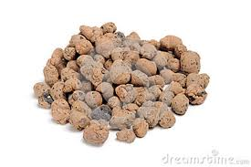

Concrete:

Limestone

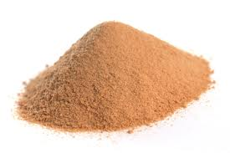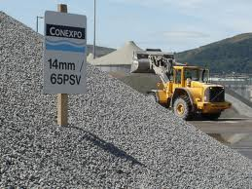

Glass:



Limestone

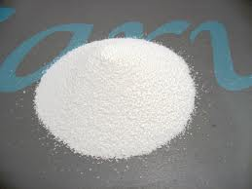

**Week 4: Metals Research**

A class of Year 10s were investigating how much copper they could get from copper sulphate.

* set up the electrolysis as shown in the diagram.
* weighed the negative electrode at the start of the experiment.
* put the electrode in the copper sulphate solution and put a current through it for exactly 60 seconds.
* weighed the mass of the electrode on an electronic balance.
* repeated this process ten times; we had to be careful not to lose any copper particles.
* subtracted the mass of the electrode at the start of the experiment from the mass of the electrode after each minute and put the results in our table.

Task

For each set of results, discuss whether you think the results are accurate, precise or reliable.

|  |  |  |  |  |
| --- | --- | --- | --- | --- |
| **Time of electrolysis (s)** | **Predicted mass of Cu (g)** | **Group 1**  **mass of Cu (g)** | **Group 2**  **mass of Cu (g)** | **Group 3**  **mass of Cu (g)** |
| 0 | 0.00 | 0.00 | 0.0 | 0.0 |
| 60 | 0.24 | 0.21 | 0.3 | 0.3 |
| 120 | 0.48 | 0.42 | 0.5 | 0.5 |
| 180 | 0.72 | 0.69 | 0.8 | 0.7 |
| 240 | 0.96 | 0.91 | 0.9 | 0.9 |
| 300 | 1.19 | 1.15 | 1.1 | 0.8 |
| 360 | 1.43 | 1.40 | 1.2 | 0.9 |
| 420 | 1.67 | 1.60 | 1.5 | 1.1 |
| 480 | 1.91 | 1.82 | 1.8 | 1.4 |
| 540 | 2.15 | 2.10 | 2.0 | 1.6 |
| 600 | 2.39 | 2.30 | 2.2 | 1.9 |

Decide ‘Yes’ or ‘No’ and mark it in the table below.

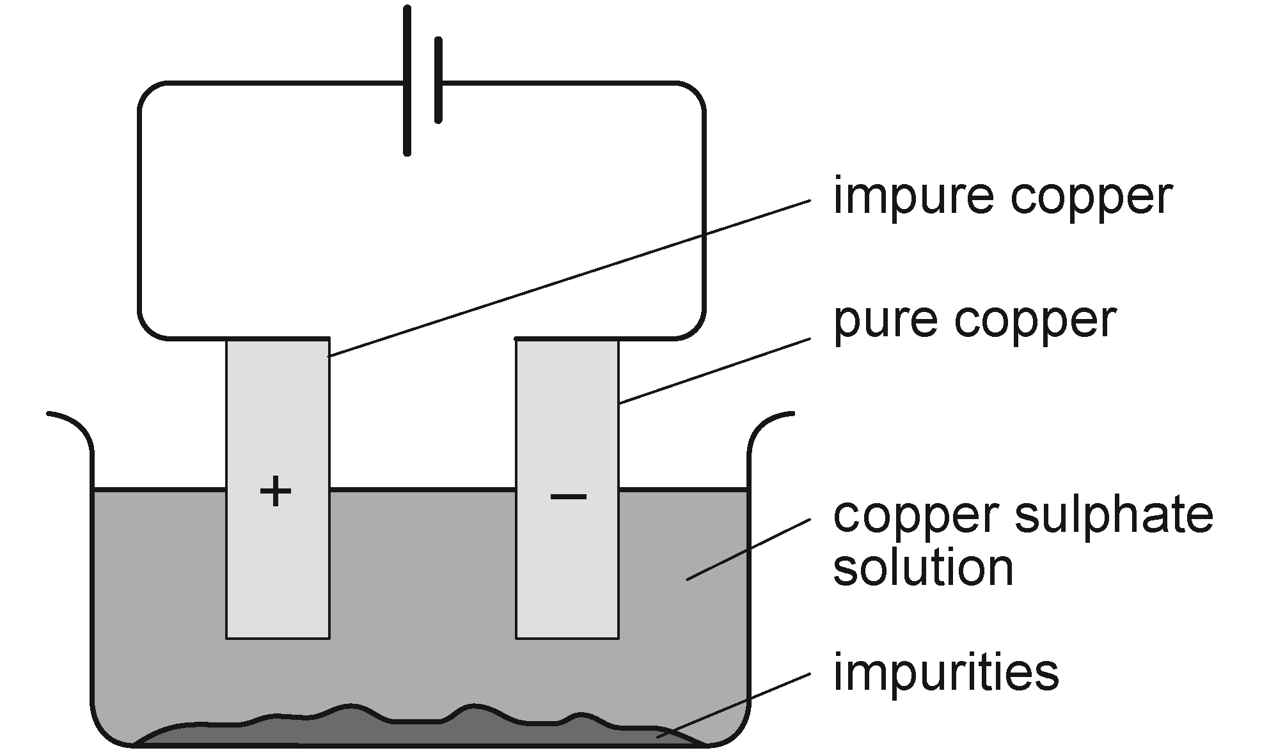

|  |  |  |  |
| --- | --- | --- | --- |
|  | **Group 1** | **Group 2** | **Group 3** |
| Accurate |  |  |  |
| Precise |  |  |  |
| Reliable |  |  |  |

**Week 5: Fractional Distillation**

Fractional distillation is the method used to separate crude oil into fractions with different boiling points. The different fractions, e.g. petrol, diesel, have different numbers of carbon atoms linked in a chain.

Task

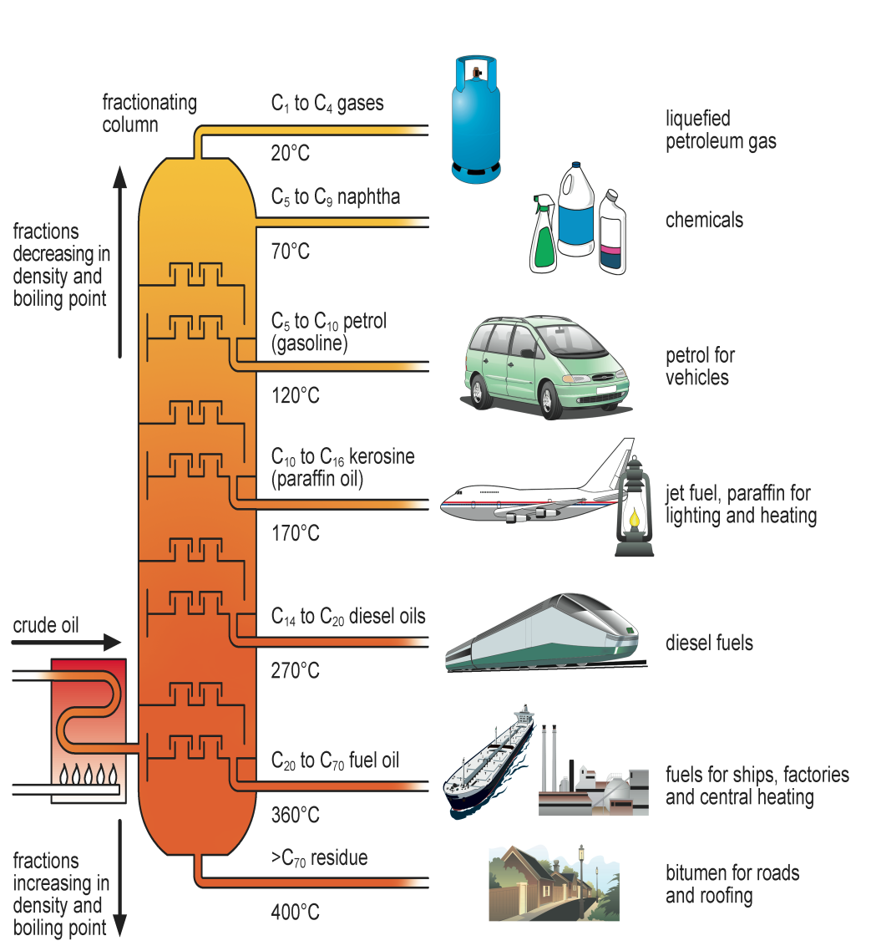

**Week 6: Plastics Research**

**Draw a graph in the box below to represent the data shown in the diagram opposite.**

What type of graph will you draw?

What will be your independent variable (*x* axis)?

What will be your dependent variable (*y* axis)?

There are two main ways of making a plastic so that it can rot away. One is to make it out of a material that bacteria consider food so that they digest it in a process called biodegradation. The other way is to make the plastic sensitive to sunlight. The sunlight can then break some of the bonds in the plastic and cause it to break down in a process called photodegradation.

## Photodegradation

There are two ways to make plastics photodegradable. Chemists can add a substance that absorbs sunlight to the plastic. The sunlight makes this substance more reactive and it attacks the polymer chains the plastic is made from. When a ‘package’ of light (a photon) hits a molecule of the added substance this molecule helps focus the energy of the sunlight in a way which causes some of the bonds in the polymer to break. The chains become fractured and brittle so the plastic falls apart.

## Biodegradation

In order for a material to be biodegradable, enzymes must be able to attack it. A plastic biodegrades when enzymes chew up (metabolise) the polymer at specific points in the chain.

They can easily snip the chemical group -CH2-CO- from the chain. Polymers such as polythene, polystyrene and polyvinylchoride do not have such bite points along the chain and so cannot be attacked. Micro-organisms can attack polythene but only slowly and not if the polythene has a molecular weight greater than about 500 – above that it is too much of a ‘mouthful’ for the enzymes. Plastics with a polythene backbone are more resistant to attack by enzymes if one or more of the hydrogen atoms is replaced with another atom or group. In PVC (polyvinyl chloride) one of the hydrogen atoms from the polythene structure is replaced by a chlorine atom; in polystyrene it is replaced by a benzene ring.

Chlorine atoms and benzene rings are completely alien to the micro-organisms so they steer clear of them. These plastics are also very resistant to moisture (water does not soak into them). The micro-organisms are carried about by water so the lack of water in these polymers makes them even harder to break down.

Items such as plastic bags are often made biodegradable by including starch in the material. Starch is a natural polymer which can be consumed quickly by bacteria. This leaves behind the synthetic polymer, but without the starch it is fragile and quickly disintegrates.

1. Explain the meaning of the terms biodegradable and photodegradable.

**Biodegradable** .........................................................................................................................

**Photodegradable** ........................................................................................................................

**PHOTOCOPYP**

1. The information sheet says: ‘Once photodegradable plastic is exposed to light it begins to break down – whether you want it to or not. This can be disastrous if it is mixed with other plastics during recycling.’ Why would this be a disaster?

...................................................................................................................................................

...................................................................................................................................................

1. ‘Polythene is biodegradable as long as it has a molecular weight of less than 500.’
2. How many ethene molecules are there in a chain with a weight of less than 500?

...................................................................................................................................................

1. Approximately how many ethene molecules are there in the polymer chains found in used polythene?

...................................................................................................................................................

1. Is the polythene used for items such as plastic bags biodegradable?

...................................................................................................................................................

1. In Ireland there is a tax on plastic bags of 5 cents in shops. The majority of Irish people now use reusable bags instead and the money funds recycling centres in every village and town. Do you think we should change to using degradable plastics or should we concentrate on recycling ordinary plastics? Consider both photodegradable and biodegradable plastics.

Produce a letter, an essay, a leaflet or a poster explaining your view. Include the science behind your arguments and explain why you have reached your conclusion.

**Week 7: Emulsions**

Oil and water are __immiscible__. However, they can be made to m____ by stirring or sh_____________ and this forms an e______________. Oil-in-water emulsions contain dr_______________ of oil suspended in the water.

**Show what you would see on the diagrams below if you had an oil and water mixture:**

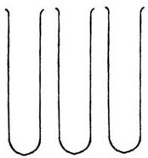

SHAKE WITH NO EMULSIFIER

SETTLE

Many emulsions are unstable and separate back to o______ and w_______. Emulsifiers help oil and water mix by stopping the oil droplets joining together to form a separate oil layer again.

**Complete the missing words in the boxes and draw in the emulsifier molecules around the oil droplet below.**

H___________ t______ which only dissolves in oil.

OIL DROPLET surrounded by WATER

H___________ h______ which only dissolves in water.

**Week 8: Plate Tectonics**

This is an EMULSIFIER

The map below shows the major plates in the Earth’s crust.

Use it to help you answer the questions.

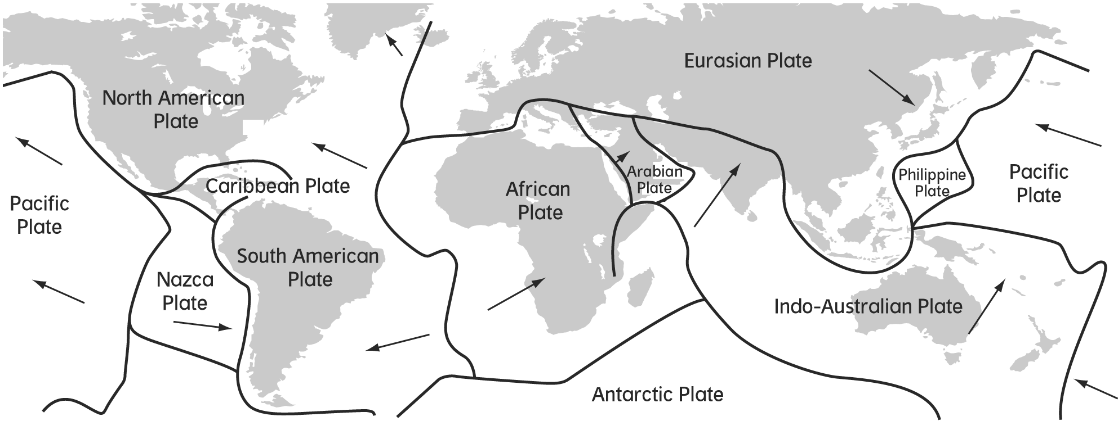

**1** Name two plates that are moving apart from each other.

**2** Name two plates that are moving towards each other.

**3** The Andes are a mountain range forming on the west coast of South America.

Explain how these mountains are being formed.

**4** There is an underwater trench in the Pacific Ocean along the west coast of South America.

Explain how this has formed.

**5** Iceland is a volcanic island in the Atlantic Ocean.

Explain how Iceland has formed and why it is volcanic.

**6** Explain why earthquakes occur at plate boundaries.