**Year 11**

**Chemistry Homework Booklet**

Name _____________________________

Class _____________________________

**Week 1: Collision Theory**

1. Name 4 conditions that will speed up a chemical reaction.

* 4 marks

1. Describe why using a higher surface area of solid will increase the rate of reaction.

2 marks

1. Describe why using a higher concentration of a solution will increase the rate of reaction.

2 marks

1. Describe why using a higher temperature will increase the rate of reaction.

3 marks

1. Why does putting gases under pressure increase their rate of reaction?

2 marks

**Week 2: Catalysts**

1. What is a catalyst? (This is a 2 mark question)
2. The activation energy is the amount of energy needed to start a reaction. How does a catalyst affect the activation energy? ____________________________________________________

**Circle the correct answers below:**

Tom has a solution of hydrogen peroxide that is decomposing very slowly.

He adds 1g of zinc oxide, which is insoluble. This acts as a catalyst.

At the end of the reaction, he filters off the insoluble zinc oxide and dries it.

He should find that the mass of zinc oxide is:

**A** 0 g because it has all reacted

**B** less than 1g but not 0g

**C** more than 1g

**D** 1g

Hydrogen peroxide solution decomposes very slowly to form water and oxygen. The addition of a small quantity of manganese (IV) oxide, as a catalyst, speeds up the decomposition. At the end of the reaction, the manganese (IV) oxide can be recovered by filtration.

Which of these statements is true?

1. if the experiment were repeated under the same conditions but using the recovered sample of catalyst, the reaction would be faster
2. the mass of the manganese (IV) oxide recovered will be more than the mass of manganese (IV) oxide at the start of the reaction
3. the manganese (IV) oxide recovered will be chemically the same as the original manganese (IV) oxide
4. if the experiment were repeated under the same conditions but less manganese (IV) oxide was used, the rate of decomposition would be the same
5. Alex investigated a reaction between a solid and a liquid. The reaction produced a gas.

Alex wanted to know if any of the substances X, Y or Z were catalysts for the reaction. He carried out the reaction without any X, Y or Z. He repeated the reaction three more times under exactly the same conditions but he added a small amount of X, Y or Z.

In each case he timed how long it took for the reaction to finish.

The results are shown the table:

State if each of X, Y and Z acted as a catalyst and give reasons for your answers. (2 Marks)

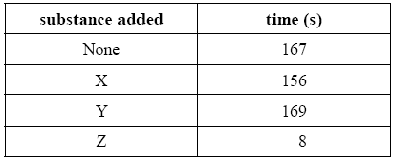

**Week 3: Exothermic and Endothermic Reactions**

1. The diagram shows some magnesium ribbon burning.

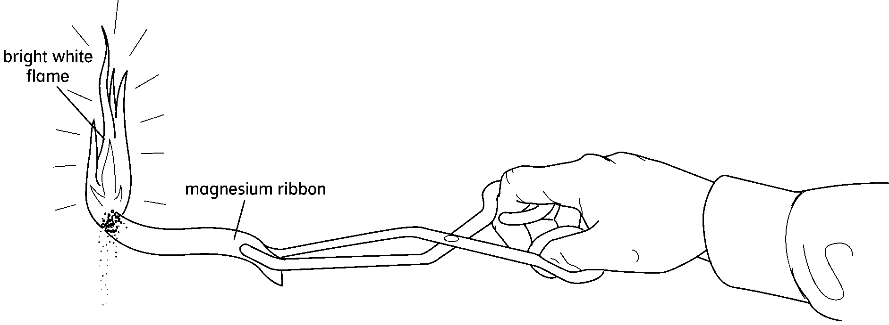

**endothermic exothermic neutralisation reduction**

**electrical heat light movement oxygen sound**

Choose some of the words from the box to complete the sentences below.

**a** When magnesium burns, it transfers ______________ energy and ______________ energy to the surroundings. We say that it is an ______________ reaction.

**b** Complete the word equation for the reaction.

magnesium + ______________ 🡒 magnesium oxide

1. Energy is transferred in chemical reactions. Look at this table.

|  |  |  |  |
| --- | --- | --- | --- |
| **Reaction** | **Starting temperature (°C)** | **Final temperature (°C)** | **Endothermic or exothermic?** |
| A + B | 19 | 27 |  |
| C + D | 19 | 25 |  |
| E + F | 20 | 19 |  |
| G + H | 18 | 29 |  |
| J + K | 18 | 18 |  |

**a** Complete the table by saying whether each reaction is endothermic or exothermic.

**b** Which pair of chemicals did not react? ______________________________________

**c** How do you know this? __________________________________________________

__________________________________________________

**d** Which reaction had the largest energy change? _______________________________

Explain the following terms:

Exothermic

Endothermic

**Week 4: Forming Ions**

The electronic configuration of sodium is 2,8,1. When sodium reacts, how does it gain a full shell of electrons? _______________________________________________________________

The electronic configuration of chlorine is 2,8,7. When chlorine reacts, how does it gain a full shell of electrons? _______________________________________________________________

How many protons and electrons do the following atoms have before they react?

11Na protons ____ electrons _____

17Cl protons ____ electrons _____

When sodium reacts it loses 1 electron; chlorine gains 1 electron.

How many protons and electrons do these atoms have after they react?

Sodium protons ____ electrons _____

Chlorine protons ____ electrons _____

**Remember protons have a charge of +1; electrons have a charge of -1.**

What would be the overall charge of each of these atoms once they have reacted?

Sodium __________ Chlorine __________

**These charged atoms are known as IONS.**

Complete the table to show what happens when different atoms gain or lose electrons to form ions. The first two have been done for you.

**(Remember: when atoms react they get full outer shells of electrons, which is two for the first shell, and eight for the next two. Metals need to lose electrons to get a full outer shell, and non-metals need to gain electrons.)**

|  |  |  |  |  |
| --- | --- | --- | --- | --- |
| **Atom** | **Gains/loses electrons** | **Number of electrons gained/lost** | **Ion** | **Metal or non-metal?** |
| Li 2,1 |  |  |  |  |
| O 2,6 |  |  |  |  |
| K 2,8,8,1 |  |  |  |  |
| Cl 2,8,7 |  |  |  |  |
| Na 2,8,1 |  |  |  |  |
| Ca 2,8,8,2 |  |  |  |  |
| F 2,7 |  |  |  |  |
| S 2,8,6 |  |  |  |  |
| Mg 2,8,2 |  |  |  |  |

**Week 5: Covalent Bonding**

1. What is a covalent bond? ______________________________

We can draw dot and cross diagrams in two ways.

Here are examples for hydrogen chloride (HCl).

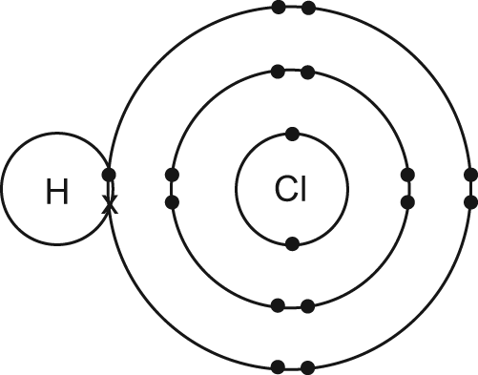

or just drawing the outer electrons

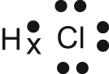

1. Draw a dot and cross diagrams for H2.

H-H

1. Draw a dot and cross diagrams for CH4.

H

H-C-H

H

1. Draw dot and cross diagrams for ethyne.

H-C≡C-H

**Week 6: Metallic Bonding**



Metal atoms release some **electrons** into the structure of the metal. These charged **particles** are free to move and are the reason why metals are good conductors of electricity. As the electrons move through the metal, they carry electrical charge through it.

**What feature of metals allows them to conduct electricity?**

_______________________________________________________________

**Describe why the structure of a metal allows it to be hammered into shape without breaking.**

_______________________________________________________________

_______________________________________________________________

**Alloys**

Most of the metals we use are not pure. Gold, for example, is too soft for most jewellery and is usually mixed with copper to make it stronger. Mixtures of metals are called **alloys**. Some alloys have been known since ancient times, such as bronze. This is an alloy of copper and tin that is much tougher than copper alone.

Alloys are often stronger than the main metal alone.

Aluminium may be used where a light metal is needed, for example in aircraft, but it is mixed with other metals such as copper and manganese to make it stronger. Smaller atoms fit into the gaps between larger atoms, disrupting the regular arrangement and making it more difficult for the layers of atoms to slide past each other.

**An alloy of tin and copper melts at just 227 °C. Why is it useful as a solder for joining electrical parts?** ____________________________________________________________



**Week 7: Acids and Bases**

Define the following chemistry keywords:

Acid: ________________________________________________

Alkali: ________________________________________________

Base: ________________________________________________

What do we call the reaction between an acid and a base? _____________

**The general formula for these reactions is:**

Acid +Base → Salt +Water

Complete the following word equations:

Hydrochloric Acid +Sodium Hydroxide → ____________ + ____________

____________

Sulphuric Acid + Calcium Hydroxide → ____________ + ____________

____________

# Making a pure salt from an acid and an insoluble base.

* If we’re making **copper sulfate** (soluble) from **sulphuric acid** (soluble) and **copper** **oxide** (insoluble)
* Firstly you would react the solid **copper oxide** and **sulphuric acid** together to make **copper sulfate** solution, but there would be a small amount of one of the reactants left unreacted as there will always be slightly more of one of them.

1. Which reactant is easier to remove from a mixture?
2. How would we remove it?
3. For which reactant would it be better to make sure that there was none left?
4. How could we make sure it was all used up?

**Week 8: Electrolysis**

**Electrolysis is using electricity to break up compounds.**

What are the products of the electrolysis of the following molten ionic compounds at each electrode?

* Tin sulfide

Cathode ________ Anode _________

* Nickel fluoride

Cathode ________ Anode _________

* Cadmium bromide

Cathode ________ Anode _________

When electrolysis is carried out, one substance will be **oxidised** and another **reduced**. We called this a **redox** reaction

At the cathode, the cation (positive ion) gains electrons and becomes neutral.

Has it been oxidised or reduced? _________

At the anode, the anion (negative ion) loses electrons and becomes neutral.

Has it been oxidised or reduced? _________

**In the reaction below:**

Cu2+ + 2Cl- → Cu + Cl2

Has the copper been oxidised or reduced? _________

Has the chloride been oxidised or reduced? _________

